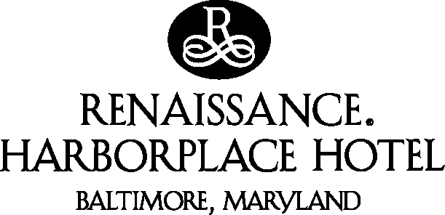

DIRECTIONS TO THE RENAISSANCE HARBORPLACE HOTEL

Via I-83:
Follow I-83 South into the city where the expressway ends. Then proceed to the third traffic light and turn right on Lombard Street. Proceed four blocks and turn left on South Street. Access to the main entrance and parking will be on your right.

Via 295 North (BWI airport):
Follow 295 North into the downtown area where it becomes Russell St.. Follow the street as it curves around the baseball stadium (Camden Yards) to your right; stay in the right lane. The second light after Camden Yards is Pratt St., make a right on Pratt. Proceed eight blocks to South St. and make a left. Access to the main entrance and parking will be on your left.

Via I-95 North (Washington D.C. area):
Follow I-95 North to Exit 53 (I-395 North, Downtown). On ramp follow signs to the Inner harbor and continue in left or center lane. At third light, turn right onto Pratt St.. Proceed on Pratt Street for five blocks then turn left on South St.. Access to the main entrance and parking will be on your left.

Via I-95 South (New York, New Jersey, Philadelphia):
Follow I-95 South through the Fort McHenry Tunnel to Exit 53 (I-395 North, Downtown). On ramp follow signs to the Inner harbor and continue in left or center lane. At third light, turn right onto Pratt St.. Proceed on Pratt Street for five blocks then turn left on South St.. Access to the main entrance and parking will be on your left.

Via I-70 East (Pittsburgh, Frederick):
Follow I-70 to exit 91 (I-695, toward Glen Burnie) proceed on I-695 to exit 11A (I95 North, Baltimore). Follow I-95 North to exit 53 (I-395 North, Downtown). On ramp follow signs to the Inner Harbor and continue in left or center lane. At third light, turn right onto Pratt St.. Proceed on Pratt Street for five blocks then turn left on South St.. Access to the main entrance and parking will be on your left.

Via I-97 North (Annapolis, Eastern Shore):
Follow I-97 North to the Baltimore Beltway (I-695 towards Towson). Proceed to I-95 North. Follow I-95 North to exit 53 (I-395 North, Downtown). On ramp follow signs to the Inner Harbor and continue in left to center lane. At third light, turn right onto Pratt St.. Proceed on Pratt Street for five blocks then turn left on South St.. Access to the main entrance and parking will be on your left.

