FIRST Membership Process for Associates

Version 1.1, August 2026
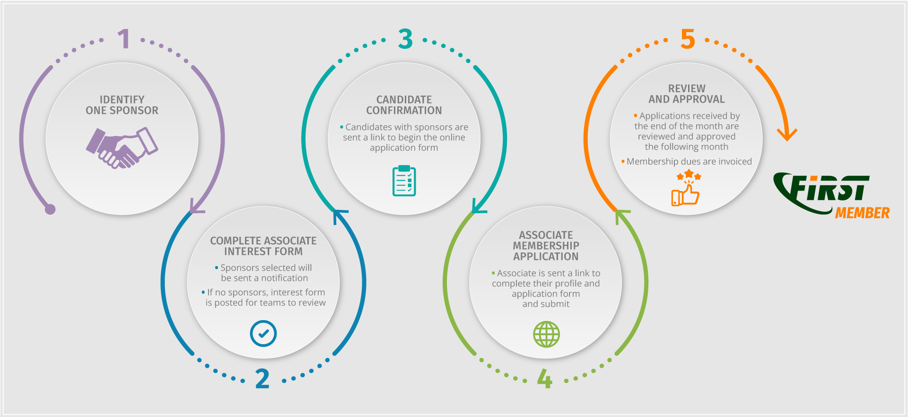
Associate membership is for organizations that are not operational incident response teams but who have a valid interest in participating in the FIRST community.
- Associate membership is an organizational but non-voting membership.
- Associate membership is for non-operational organizations and access to member tools is restricted/limited

1. Candidate finds one FIRST full member who agrees to act as Sponsor.
- The application process cannot proceed without a sponsor
- The Candidate may review the list of current teams to find a sponsor.
- The Candidate may reach out to teams they have worked with or in their industry/region.
- If a candidate needs a sponsor – they may consider attending a FIRST event or joining a FIRST SIG to network and meet potential sponsors.

2. Candidate completes the Associate Membership Interest Form
The Candidate creates a profile for the FIRST Portal and then completes the Membership Interest Form. Once the form is validated by the Secretariat, the candidate and sponsor will be sent a link to start the application form.

3. Candidate completes the Associate Member Application Form
The Candidate must complete the FIRST Membership Application Form on FIRST Portal. Non-profit and not for profit organizations must provide a certificate of non-profit status from a tax authority.
Information provided in the application form will be used to update the Associate profile in the FIRST Portal. By applying to FIRST, the candidate agrees to review this information annually for accuracy and provide regular updates.

4. Sponsors review and letter of support
The Sponsor validates the application and uploads their letter of support. Sponsors can use Annex 1 as a template.

5. Candidate submit for review
Candidate reviews the application for completion and submits the Application Form.

6. Review and Approval Process
- The review process begins on the 1st of the month following submission:
- The Secretariat reviews the application for completeness (week 1)
- The Membership Committee reviews and submits feedback/questions (week 2)
- Members review the list of applicants for comment (week 2)
- The Board approves applications (week 3)
- Notifications are sent to teams following the monthly board meeting (week 3)
Estimated duration of review period – 3-4 weeks
If any issues or objections are identified, the FIRST Secretariat takes this back to the Candidate and the Sponsors for resolution. Rejected teams have the right to re-apply at any time.

