FIRST Membership Process for Teams

Version 2.2, August 2026
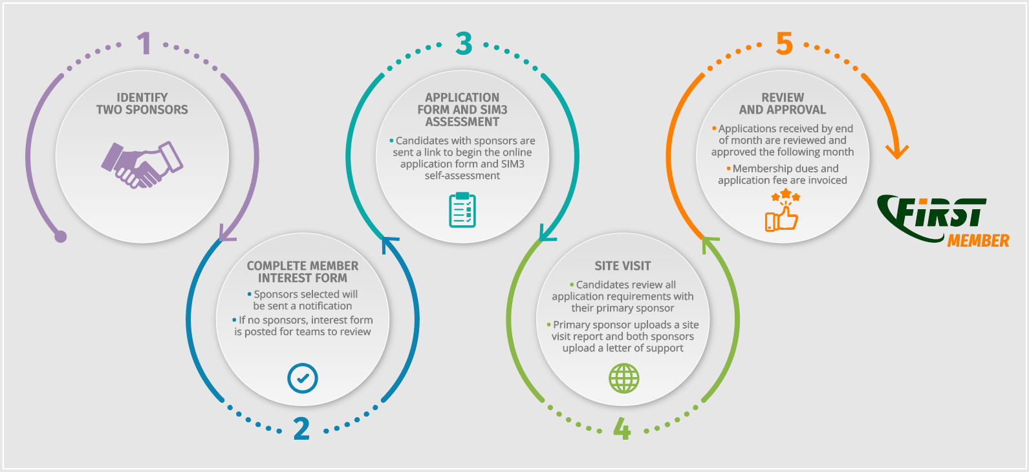
Following is the process of becoming a FIRST Full Member (teams only). Applying team is the ‘candidate.’

1. Candidate identifies two FIRST full members as Sponsors
- The member interest form cannot proceed to the application without sponsors.
- The Candidate may review the list of current teams to find sponsors.
- The candidate may attend a FIRST event to meet sponsors
- The Primary sponsor should be from outside the Candidates host/parent organization.
- It is the candidates’ responsibility to identify sponsors. The FIRST Secretariat may be contacted to assist with introductions but the candidate should provide potential sponsoring teams.

2. Candidate submits Membership Interest Form
Candidate representative(s) to create a profile for the FIRST Portal and completes/submits the Membership Interest Form. Once validated by the Secretariat, the candidate and sponsors will be sent to the application.

3. Candidate performs SIM3 self-assessment
Candidate completes the Security Incident Management Maturity Model (SIM3) self-assessment and reviews results with the primary sponsor.

4. Sponsors conduct Site Visit
Candidate contacts the primary sponsor to schedule the site visit (in person or virtual). Review the Site Visit template report to prepare the requested materials/documents in Annex 2. The primary sponsor drafts a report using the template at Annex 7. Any area of the report that does not apply should be explained.

5. Candidate completes the Full Member Application Form
The Candidate must complete the FIRST Membership Application Form on FIRST Portal.
Information provided in the application form will be used to update the teams profile in the FIRST Portal. By applying to FIRST, the candidate agrees to review this information annually for accuracy and provide regular updates to team details and confirm team members.

6. Sponsors review application and attach letters of support
Both sponsors review the application form including the SIM3 score and site visit report. Sponsors upload their letters of support recommending the team. Sponsors can use the template at Annex 4.

7. Sponsor or candidate submit for review
Once all boxes on the application are checked, sponsor or candidate submit the Application Form.

8. Review and Approval Process
The review process begins on the 1st of the month following submission:
- The Secretariat reviews the application for completeness (week 1)
- The Membership Committee reviews and submits feedback/questions (week 2)
- Members review the list of applicants for comment (week 2)
- The Board approves applications (week 3)
- Notifications are sent to teams following the monthly board meeting (week 3)
Estimated duration of review period – 3-4 weeks
If any issues or objections are identified, the FIRST Secretariat takes this back to the Candidate and the Sponsors for resolution. If needed, the process loops back to step 7. Rejected teams have the right to re-apply at any time.

