FIRST Membership Process
for Individual Members

Version 2.2, August 2026
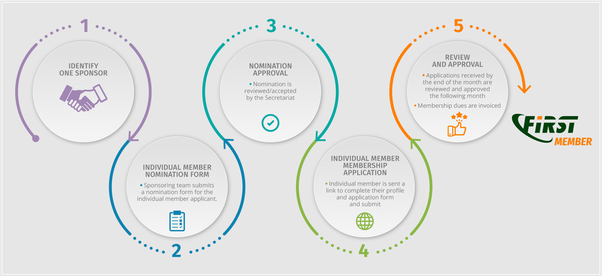
The following is a detailed process of becoming a FIRST Individual Member (formerly known as liaison members).
Please note that:
- Individual membership access/benefits only apply to that individual.
- An individual member can change companies/hosts and the membership remains with the individual.

1. A full (team) member nominates an individual for membership (candidate).
It is the candidate’s responsibility to find a sponsoring team to nominate them to start the process.
- The Candidate may reach out to teams they have worked with or who are in their industry/region. A list of teams can be found here.
- The sponsor may be a former team if the individual has moved on from that company.
- Candidates may consider attending a FIRST event or joining a FIRST SIG to network and meet potential sponsors.

2. Sponsor submits the Individual Nomination Form
The sponsor completes the form FIRST Portal > Membership Application. Once accepted by the Secretariat, the sponsor and candidate will receive an e-mail with instructions for the candidate to create a profile for FIRST Portal.

3. Candidate completes the Application Form
The nominated individual completes the application required fields including a statement of reasons they want to join FIRST and the benefits they intend to bring to the FIRST community.
Information provided in the application form will be used to update the liaison profile in the FIRST Portal. By applying to FIRST, the candidate agrees to review this information annually for accuracy and provide regular updates.

4. Candidate submits for review
Candidates confirms the sponsor letter is uploaded on the FIRST portal and then submits the Application.

5. Review and Approval Process
The review process begins on the 1st of the month following submission:
- The Secretariat reviews the application for completeness (week 1)
- The Membership Committee reviews and submits feedback/questions (week 2)
- Members review the list of applicants for comment (week 2)
- The Board approves applications (week 3)
- Notifications are sent to applicants following the monthly board meeting (week 3)
Estimated duration of review period – 3-4 weeks
If any issues or objections are identified, the FIRST Secretariat takes this back to the candidate and the Sponsors for resolution. Rejected individuals have the right to re-apply at any time.

